**JAPAN FILM FESTIVAL at the Official Residence of the Consul General**

**(27 February, 2025)**

On 27 February, the Consulate General of Japan in Dubai hosted the "Japan Film Night" as part of the Japan Foundation’s Japanese film screening program, where students from the Japan Clubs of Zayed University and the American University in Dubai (AUD) were invited to the Official Residence of the Consul General.

The featured film of the “Japan Film Night” was the Japanese live-action movie "AWAKE". This event sparked greater interest in Japan and provided a valuable opportunity for participants to deepen their understanding of Japanese culture.

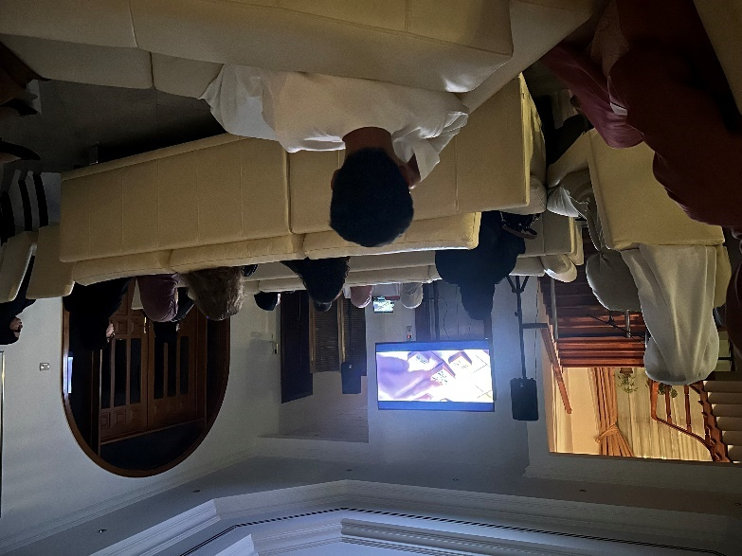

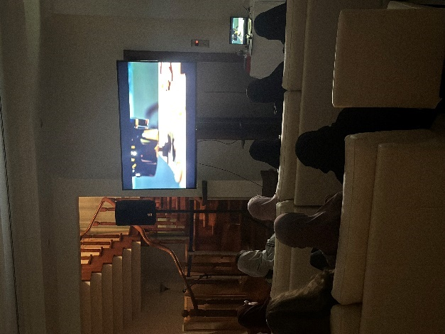

[Screened Film]

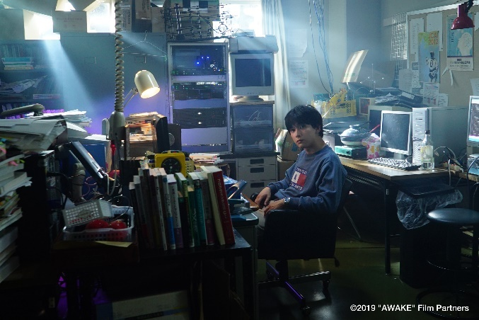「AWAKE」

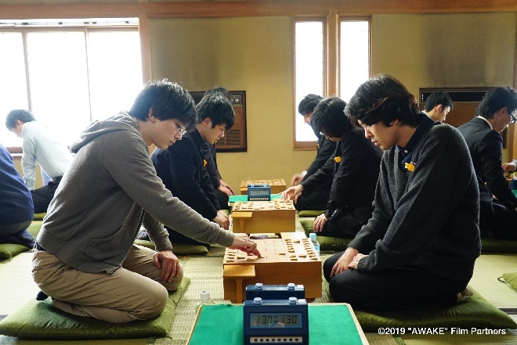

[Co-host]

